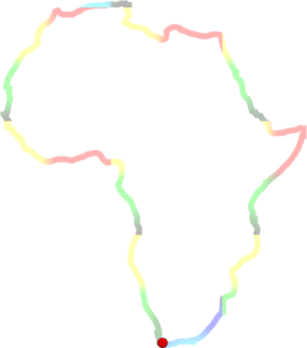
AfriNEAD 2014: “Intensifying disability research and practice to achieve the MDGs in Africa:our experience and espirations for the future”

Hosted by the University of Malawi, Ministry of Disability and Elderly Affairs , the Federation of Disability Organizations in Malawi (FEDOMA), CBM and Stellenbosch University

3 – 5 November 2014
Sun ‘N’ Sand Holiday Resort, Mangochi, Malawi

REGISTRATION FORM

Title: First name: Surname:
Postal address:

Country: ……………………………………………………………………………… Postal code:
Tel: ( ) Fax: ( )
Email (please print clearly):
ID Number:
Professional / tertiary qualifications (if applicable):
Employer / institution:
Position held:
Type of delegate………………………………………………………………………………………………… Local
International

REGISTRATION FEES:
Early registration by 31st July 2014: USD370.00. Late registration after 31st July 2014:USD470.00 for the full conference and Registration on site: US$500.

PRE-CONFERENCE INFORMATION:
All pre-conference information, including your registration acknowledgement letter, will be sent to your email address. If you have not specified an email address, information will be sent to you by regular post to the postal address you have specified on this form.

SPECIAL NEEDS:
Are you a wheelchair user? Yes / No
Will you be bringing a guide dog? Yes / No
Will you be bringing an assistant? Yes / No
Will you require the documentation you receive at the conference in:
- braille Yes / No
- audio cassette form Yes / No
- electronic form Yes / No
Will you require sign interpretation? Yes / No
Do you have any other special needs of which we should be aware? Yes / No
If yes, please indicate:

DIETARY REQUIREMENTS:
If you have dietary requirements, please indicate below:
- vegetarian Yes / No
- Halaal Yes / No
- Kosher Yes / No

PAYMENT INFORMATION:
- Bank deposits: Please deposit your registration fees into the following account:
Bank: National Bank of Malawi
Account name: University of Malawi-CSR
Account number: 294136
Bank Address: P.O. Box 13, Zomba, Malawi
Swift Code: NBMAMWMW006
Reference: Please write the delegate’s surname on the deposit slip as a reference
Please fax a copy of your deposit slip together with your registration form to (+265) 1 524578
- Internet transfers: Please fax proof of payment together with your registration form to (+265) 1 524578
- Credit cards: Please debit my card: Master Card Visa American Express
Card Number:

Expiry Date: | M | M | Y | Y | Signature:

Cancellation of registration to the Conference
Any cancellation received by the secretariat will be subjected to the following refund policy:
- 75% of the amount paid if written cancellation is received prior to 31st July 2014
- No refund if written cancellation is received after 31st July 2014

Please return your completed form and payment to:
University of Malawi, Organising Committee, AFRINEAD Symposium, P.O. Box 13, Zomba. MALAWI .
Tel: (265) 1 524 800 Fax: (265) 1 524 578 Email: afrinead-conf@cc.ac.mw

REGISTER ONLINE AT: www.sun.ac.za/afrinead

