WHO Priority Assistive Products List (APL)
Global Survey
Background:
We need more than a billion assistive products now and 2 billion by 2050. However, today only 1 in 10 persons in need has access to assistive products (AP). To change this scenario, based on the success and learning of Essential Medicines List (EML), WHO is developing a WHO Priority Assistive Products List (APL) to assist Member States to plan policies and programmes related to the provision of AP. Like the EML, the main goal of this initiative is to improve access to high-quality affordable assistive products. Towards this, WHO is launching a global survey to identify 50 most Priority Assistive Products.
All stakeholders, especially the users/potential users or their family members/organizations are specially encouraged to take part in this survey. Please share this survey with your colleagues and friends. Please complete this survey online or download the survey form and send the completed survey after selecting the 50 most Priority Assistive Products to assistivetechnology@who.int.
Should you agree, please fill up your personal details in order to enable us to keep in touch and inform you about progress related to this endeavour. All survey result will be analysed anonymously and no personal identifiers will be linked to the individual responses . All information will remain confidential.
Thank you for your participation in this exercise.
Chapal Khasnabis (khasnabisc@who.int)
Global Cooperation on Assistive Technology (GATE)
http://www.who.int/phi/implementation/assistive_technology/phi_gate/en/

Your personal details:
Name: ____________________________________________________________________________
Age: ______________ Sex: Male Female
Country: __________________E-mail: ________________________ Mobile/telephone no. + __________________
Do you have a disability? Yes No Do you use any assistive product/device? Yes No
If yes, what kind? Mobility Vision Hearing Communication Cognition Environment
Would like to be contacted in the future? Yes No

1. Mobility
√Tick maximum 16 products which you consider important

Area | Name of Product  (ISO Code) |  |  | Explanation
Crutches | 1 | Axillary crutches  12.03.12 | 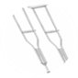 | Devices providing support when walking that have a horizontal padded support that is placed against the upper body next to the armpit | ☐
 | 2 | Elbow crutches  12.03.06 | 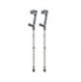 | Devices, adjustable in height, providing support when walking that have a semi-circular support for the elbow, a horizontal hand grip, a single shaft, and one tip | ☐
Walking sticks and canes | 3 | Walking sticks/canes  12.03.03 | 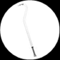 | Adjustable/non-adjustable mobility device with a handgrip | ☐
 | 4 | Tripod/Quadripod sticks  12.03.16 | 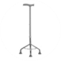 | Device providing support when walking that has a single shaft that branches into three or four shafts, each of which ends with a non-slip tip (ferrule) | ☐
Walkers | 5 | Walking frames  12.06.03 | 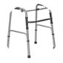 | Frame that helps a person to maintain stability and balance while walking or standing, with either four tips (ferrules) or two tips and two castors | ☐
 | 6 | Rollators  12.06.06 | 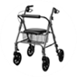 | Frame that help a person to maintain stability and balance while walking, that has hand grips and three or more wheels (with or without a platform) | ☐
Wheelchairs | 7 | Manual wheelchairs –basic type for active users  12.22.03 | 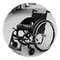 | Intended to be self-propelled by the users by pushing rims or wheels. Can be used indoor/outdoor and on various types of terrain. | ☐
 | 8 | Manual wheelchairs - push type | 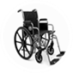 | Only for indoor use and limited outdoors, pushed by an attendent | ☐
 | 9 | Manual wheelchairs – intermediate/advanced type  12.22.03 | 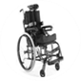 | Manual wheelchairs with postural support that can be adjusted to the individual user’s needs | ☐
 | 10 | Sports wheelchairs  12.22.03 | 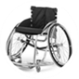 | Light-weight wheelchairs for sports. | ☐
 | 11 | Electrical wheelchairs  12.23.06 | 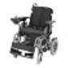 | Wheelchair powered by battery | ☐
 | 12 | Electrical wheelchairs with postural support  12.23.06 | 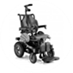 | Wheelchairs with postural support powered by battery | ☐
 | 13 | Tricycles (three-wheeled cycles)  12.18.09 | 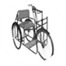 | Trikes or three-wheeled cycles for greater mobility and mostly for outdoor use | ☐
Lower limb orthoses | 14 | Foot Orthoses (FO)  06.12.03 | 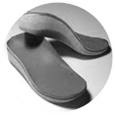 | Orthosis that encompass the whole or part of the foot. Included are, e.g.: insoles and shoe inserts, pads, arch supports, heel cushions | ☐
 | 15 | Footwear for diabetes/neuropathic foot  06.33.30 | 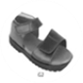 | Orthopaedic shoes to reduce or distribute load on tissue to prevent injuries in the development of a diabetic foot | ☐
 | 16 | Orthopaedic shoes or footwear  06.33.30 | 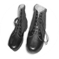 | Footwear intended to treat or compensate for the impaired body functions or body structures of a person's leg, ankle and foot | ☐
 | 17 | Foot abduction braces/ Club foot braces/splints |  | Device used in the treatment of club foot | ☐
 | 18 | Ankle Foot Orthoses (calliper/brace) (AFO)  06.12.06 | 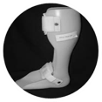 | Orthosis that encompasses the ankle joint and the whole or part of the foot | ☐
 | 19 | Knee orthoses (calliper/brace) (KO)  06.12.09 | 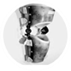 | Orthosis that encompasses/supports the knee joint | ☐
 | 20 | Knee ankle foot orthoses (calliper/brace) (KAFO)  06.12.12 | 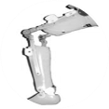 | Orthosis that encompasses the knee and ankle joints and the foot | ☐
Upper limb orthoses | 21 | Hand splints (cock-up/wrist immobilizer)  06.06.12 | 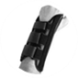 | Used to stabilize (immobilize) the wrist and hand in the desired position to rest the joint, tendons, ligaments or maintain a certain bone alignment | ☐
 | 22 | Static wrist-hand orthoses (WHO) /splints  06.06.12 | 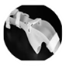 | Orthosis that encompasses the wrist joint and the hand to maintain functional position of the hand and prevent wrist and hand deformities | ☐
 | 23 | Shoulder slings | 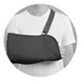 | A sling is a bandage used to support an injured arm | ☐
Spinal orthoses | 24 | Thoraco-lumbo-sacral orthoses/brace  06.03.09 | 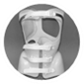 | Orthosis that encompasses the whole or part of the thoracic, lumbar and sacro-iliac regions of the trunk | ☐
 | 25 | Cervical orthoses  06.03.12 | 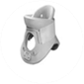 | Orthosis that supports the whole or part of the cervical spine | ☐
Lower limb prostheses | 26 | Below knee lower limb prosthesis (artificial leg)  06.24.09 | 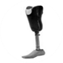 | Device that replaces part of the lower limb between the knee joint and the ankle joint after amputation or in cases of limb deficiency (includes trans-tibial, foot prosthesis and partial foot prosthesis) | ☐
 | 27 | Above knee lower limb prosthesis (artificial leg)  06.24.15 | 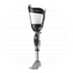 | Device that replaces part of the lower limb between the hip joint and the knee joint after amputation or in cases of limb deficiency (includes trans-femoral, knee disarticulation and hip disarticulation prosthesis) | ☐
Upper limb prostheses | 28 | Trans-humeral (above elbow) upper limb prosthesis (artificial hand)  06.18.15 | 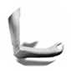 | Device that replaces part of the upper limb between the shoulder and elbow joints after amputation or in cases of limb deficiency | ☐
 | 29 | Trans-radial (below elbow) upper limb prosthesis (artificial hand)  06.18.09 | 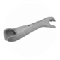 | Device that replaces part of the upper limb between the wrist and elbow joints after amputation or in cases of limb deficiency | ☐
Special devices for children with developme-ntal delays | 30 | Adjustable walkers for children | 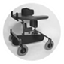 | Assists children with any kind of developmental delays to walk | ☐
 | 31 | Table/seating frames | 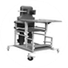 | Specially designed seat and desk for children with any kind of developmental delay for seating and standing | ☐
 | 32 | Adjustable standing frames  04.48.08 | 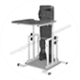 | Standing frame that provides angle adjustable supine and prone full body support option for children with range of mobility and developmental delay | ☐

2. Vision
√Tick maximum 9 products which you consider important

Area | Name of Product  (ISO Code) |  | Explanation
Spectacles | 33 | Spectacles for short distance/Reading glasses  22.03.06 | 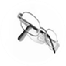 | Eyeglasses that help correct close-range vision issues for selected fixed power range | ☐
 | 34 | Spectacles for long distance  22.03.06 | 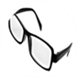 | Distance glasses focus on things that are further away in positive selected power grades | ☐
 | 35 | Eyeglasses for low vision  22.03.06 | 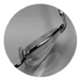 | Special glasses for Gross magnification (of selected positive power) | ☐
Magnifying devices | 36 | Magnifying glasses  22.03.09 |  | convex lens that is used to produce a magnified image of an object | ☐
 | 37 | Hand-held digital magnifiers  22.03.18 | 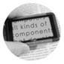 | portable systems that display an enlarged image of a close object captured by a video camera | ☐
 | 38 | Pc Magnifiers |  | Magnification and screen reading software for the visually impaired and helps countless individuals  Some features Color Enhancement Transition Effects- Smooth Mouse Pointers | ☐
Tactile sticks | 39 | White canes (folding or non-folding)  12.39.03 | 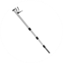 | Devices for navigation or identification of the surroundings used by a person with a visual impairment | ☐
Interactive  products | 40 | Refreshable braille displays  22.39.05 | 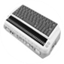 | Electro-mechanical device for displaying braille characters, usually by means of round-tipped pins raised through holes in a flat surface | ☐
 | 41 | Text to speech software | 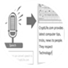 | Software that reads selected text | ☐
 | 42 | Screen readers  22.39.12 |  | Software that interprets what is being displayed on the screen and presents it to the user with text-to-speech, sound icons, or a Braille output | ☐
 | 43 | Screen Reader for Smart Phone/tablet | 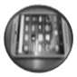 | Communication device with screen reading software also used for reading books and newspaper and also for GPS based navigation. | ☐
Products for writing | 44 | Portable braille note takers  22.12.21 | 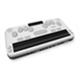 | Portable devices that use either a Braille or keyboard for input and voice and/or refreshable Braille for output | ☐
 | 45 | Braille Printers |  | Printer that generates Braille embossed paper documents | ☐
 | 46 | Braille writing equipment  22.12.12 | 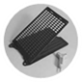 | Devices for manual Braille input entry for producing Braille onto paper | ☐
 | 47 | Braille translation software  22.39.12 | 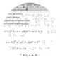 | Braille translation software converts electronic files into Braille | ☐
 | 48 | Automatic Speech Recognition software | 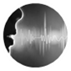 | Software for transcription of spoken language into readable text on a screen in real time | ☐
Talking devices | 49 | Talking calculators  22.15.06 | 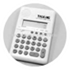 | Calculating device that presents calculations in sounds | ☐
 | 50 | Talking/touching watches  22.27.12 | 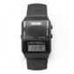 | Timekeeping device that presents the time as sounds | ☐

3. Hearing
√Tick maximum 7 products which you consider important

Area | Name of Product  (ISO Code) |  | Explanation
Hearing aids | 51 | Body worn hearing aids  22.06.06 | 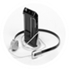 | Device worn attached to the person's clothes or hanging around her/his neck that amplifies sound | ☐
 | 52 | Behind the ear hearing aids  22.06.15 | 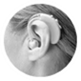 | Devices worn behind the ear to amplify sound. | ☐
 | 53 | In the ear or in the canal hearing aids  22.06.12 | 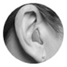 | Partial or completely in the canal. Devices worn in the ear or in the year canal to amplify sound. | ☐
 | 54 | Hearing aid rechargeable batteries and chargers | 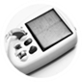 | Devices to re-charge hearing aid batteries using electric/solar power | ☐
Communica-tion products | 55 | Amplified telephones  22.24.03 |  | Type of telephone that is designed to amplify sound for people with a hearing impairment | ☐
 | 56 | Video communication devices |  | Device that allows for interaction achieved by means of a video link | ☐
 | 57 | Text to Text Communication Device | 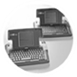 | Wired/wireless (often battery operated) real time text-to-text communication among 2 - 4 people | ☐
 | 58 | Device/software for gesture to voice technologies | 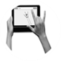 | Sign language is converted into speech and speech into text or sign language | ☐
 | 59 | DeafBlind Communicator (DBC) | 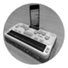 | Consists of a Braille note-taker linked by Bluetooth to a mobile phone | ☐
Signalling products | 60 | Doorbell indicators  22.27.03 | 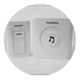 | Flashing device activated when doorbell rings | ☐
 | 61 | Fire and smoke alarm signallers  22.27.09 | 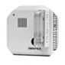 | Flashing strobe light and/or a vibrating pad that can be placed under the pillow which activate when the smoke alarm sounds | ☐
 | 62 | Vibrating multi-sound wrist bracelets  22.27.09 | 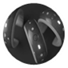 | Notifies user with vibrations when different sounds are detected (e.g. telephone, doorbell, baby-cry, etc.) | ☐
Other products | 63 | Captioning TVs  22.18.21 | 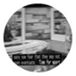 | Audio portion of the television program is converted into written words, which appear in a window on the screen. | ☐
 | 64 | Automatic speech recognition in captioning systems | 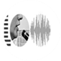 | Auditory information picked-up by an ASR is translated into text and displayed for the deaf user | ☐

4. Communication
√Tick maximum 4 products which you consider important

Area | Name of Product  (ISO Code) |  | Explanation
Non-electronic AAC | 65 | Communication boards/books  22.21.03 | 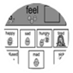 | Communication displays consisting of photographs, symbols, words/letters or a combination of all three | ☐
 | 66 | Communication cards  22.21.03 | 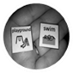 | Users point to the picture representing need or exchange picture for object depicted | ☐
Electronic AAC | 67 | Face-to-face communication software  22.21.12 | 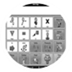 | Software for direct communication - based on symbols or text - which supplements or replaces speech or verbal communication | ☐
 | 68 | Symbols generating software | 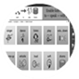 | Enables the creation of individualised low/no technology communication tools (i.e. communication boards/books/cards) | ☐
 | 69 | AAC apps | 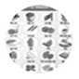 | Augmentative and Alternative Communication (AAC) application for SMART phones to facilitate communication | ☐
Accessories | 70 | Head mouse |  | Helps paralyzed people interact with computers, using head movements to perform common operations such as typing, copying and pasting | ☐
 | 71 | Head-mouth sticks  24.18.15 | 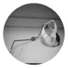 | Accessory mounted to the head or mouth used as a keyboard aid, a pencil holder, accessing a communication board or for turning pages | ☐
 | 72 | Keyboard and mouse emulation software  22.36.18 | 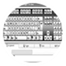 | Software that reproduces the keyboard on the device screen and/or allows control of mouse pointer movement and/or click functions. | ☐

5. Cognition
√Tick maximum 9 products which you consider important

Area | Name of Product  (ISO Code) |  | Explanation
Multiple uses | 73 | Personal Digital Assistants (PDA)  22.33.06 | 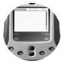 | Computers that can be powered with batteries and thus can be used anywhere - includes mobile phones such as smartphones and tablets | ☐
Memory Aids | 74 | Recorders (Dictaphone)  22.18.08 | 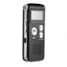 | Portable devices that can record, store, and replay audible information to facilitate the recall of facts or appointments | ☐
 | 75 | Watch with pre-programmed task reminders | 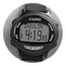 | Watch that can be programmed by user or by carers with audible alarms or text messages that bring the user attention to a task | ☐
 | 76 | Pill organizers  04.19.04 | 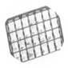 | Special container for storing scheduled doses of one's medications to keep track of whether or not the user has taken the medication | ☐
Time devices | 77 | Visual timers |  | Operated by the user or support person to enable the user to stay on task, complete task on time, wait without anxiety among many other uses | ☐
 | 78 | Time orientation products | 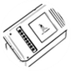 | Products that support orientation in time (year, season, month, date, weekday, part of day, clock-time). | ☐
 | 79 | Time management products  22.27.15 | 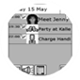 | Products that support ordering events in chronological sequence and allocating amounts of time to events and activities. | ☐
Locator devices | 80 | Portable GPS trackers | 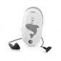 | Small portable GPS devices that come in different shapes and sizes and are powered by batteries | ☐
 | 81 | GPS locator watch/locator | 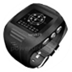 | GPS tracking device integrated in watch or in another object that can be carried | ☐
 | 82 | Item locators | 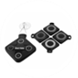 | Devices that can help locate commonly mislaid items in the home such as keys, wallets, glasses case etc. or warn user when any tagged items have wandered outside of a user-set boundary | ☐
Navigation devices | 83 | Portable navigation aids  12.39.06 | 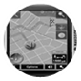 | Product that supports users to walk from one location to another | ☐
 | 84 | Portable travel aids | 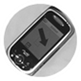 | Product that supports user to travel from one location to another, with route data and information on public transportation services, payments and outdoor navigation | ☐
Communi-cation and language tools | 85 | Simplified mobile phones | 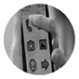 | Easy to use mobile phones i.e. easy interface, big buttons for facilitating calling or texting, etc. | ☐
 | 86 | Word completion programs  22.12.24 | 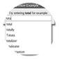 | Programs that predict whole words on the basis of the first few letters typed by the user | ☐
 | 87 | Picture based navigation software | 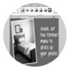 | Takes through pre-programmed daily-living tasks, step-by-step using pictures for each step | ☐
Alarms | 88 | Personal emergency alarm systems  22.27.18 | 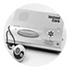 | Device either operated by the user or activated automatically in case of personal emergency to notify the user or obtain help from another individual or service | ☐
 | 89 | Fall detectors | 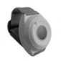 | Fall detectors are worn by the person and will trigger an alert to a carer if an impact is detected and/or the person remains in a lying position. The device then sends an alarm signal to a carer or monitoring centre | ☐
 | 90 | Medical Alert ID | 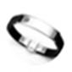 | Smart ID allows for communication of medical conditions and emergency contact information | ☐

6. Environment
√Tick maximum 5 products which you consider important

Area | Name of Product  (ISO Code) |  | Explanation
Handrails and grab bars | 91 | Handrails and support rails  18.18.03 | 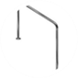 | Bars, usually cylindrical, attached to a wall, floor or other stable structure that provide the means for a person to support or stabilize himself | ☐
 | 92 | Grab bars and handgrips (fixed or removable)  18.18.06 / 18.18.10 | 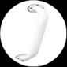 | Straight or angled bars that provide support to a person while changing position, standing or walking | ☐
Assistive products for washing | 93 | Shower chairs  09.33.03 | 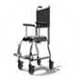 | Waterproof chair/stool with or without castors that support seating in the shower. It may include armrests, adjustable height legs, and reclining facilities. | ☐
 | 94 | Bath/shower seats  09.33.03 | 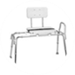 | Devices for supporting sitting during bathing or showering | ☐
Assistive products for toileting | 95 | Toilet seat raisers  09.12.15 | 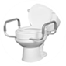 | Raised toilet seats that can easily be removed from the WC pan | ☐
 | 96 | Commode chairs  09.12.03 | 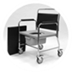 | Chairs, with or without castors, with a built-in collection receptacle used for toileting away from the bathroom | ☐
Beds | 97 | Pressure relief mattress  04 33 06 | 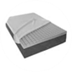 | prevent pressure injuries by dispersing pressure away from bone protrusions | ☐
Wheelchair accessories | 98 | Pressure relief cushions  04.33.03 | 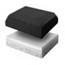 | Device for tissue integrity through redistribution of the load on the buttocks | ☐
 | 99 | Portable ramps  18.30.15 | 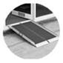 | Moveable sloping surfaces that bridge a limited gap between two levels | ☐
 | 100 | Sliding boards, sliding mats and turning sheets  12.31.03 | 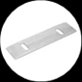 | Devices for changing position or direction of a person sitting or lying, using sliding techniques. | ☐

