[PERSONALIZED EMAIL TOPPER FROM BENEFIT STAFF]

MISSED THE CONFERENCE? GET CAUGHT UP AND HELP SPREAD THE WORD

Recently, BENEFIT Kids was honored to present the results of several key studies addressing multidrug-resistant tuberculosis (MDR-TB) prevention and treatment for children at the Union World Conference on Lung Health in Paris.

Treatment of MDR-TB in children still lags dramatically behind recent advances in adult MDR-TB treatment, and the studies addressed these key evidence gaps and barriers — informing efforts to produce more child-friendly, better tasting medicines and formulations, as well as to improve uptake, acceptability and outcomes among children.

Learn more about BENEFIT Kids and the information we presented at the Union Conference at our refreshed website and please consider sharing the news articles and graphics with your networks and on your social channels to help us spread the word about these critical findings and their impact.

HELP SPREAD THE WORD

Media coverage from the Union Conference to share:

- NPR: "WHO says we can ‘write the final chapter in the story of TB.’"
- BBC Africa: "Drug trial offers hope for TB prevention"
- Devex (US): "Study: Common antibiotic reduces risk of drug-resistant TB"
- Agence France-Presse: "Common drug halves risk of drug-resistant tuberculosis"

Talking points to use in social media posts:

- Children with multidrug-resistant tuberculosis (MDR-TB) are a neglected population suffering from a largely neglected disease.

- Right now, the treatment journey for children with MDR-TB and their caregivers can be unnecessarily long and harrowing.

- Most of the drugs currently given to children with MDR-TB were developed 50 to 60 years ago, are more painful and less effective, and have unpleasant side effects.

- There has been progress made on adult treatment, but children aren’t just “little adults” — and developing drug formulations for children poses unique challenges.

- BENEFIT Kids is dedicated to researching and accelerating the adoption of innovative MDR-TB treatment regimens and prevention methods for children of all ages, in order to reduce illness and death among this vulnerable population.

- Supported by funding from Unitaid, BENEFIT Kids is bridging knowledge gaps and producing critical evidence on dosing, safety, and efficacy.

Infographics and factsheets to use:

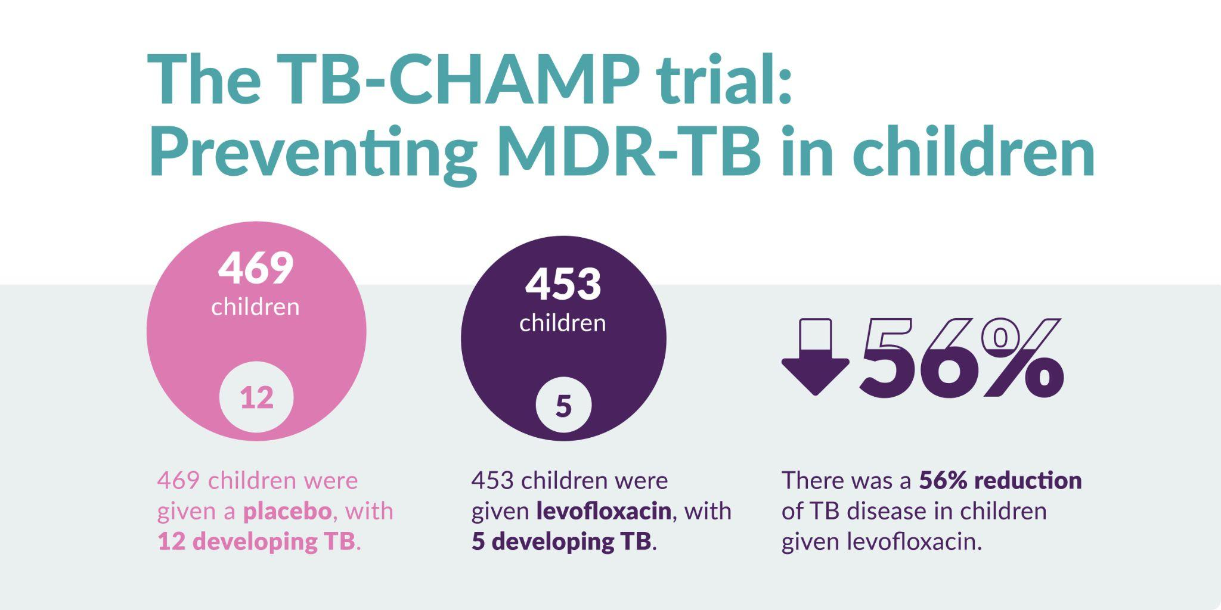
Download this graphic (and the full factsheet) here

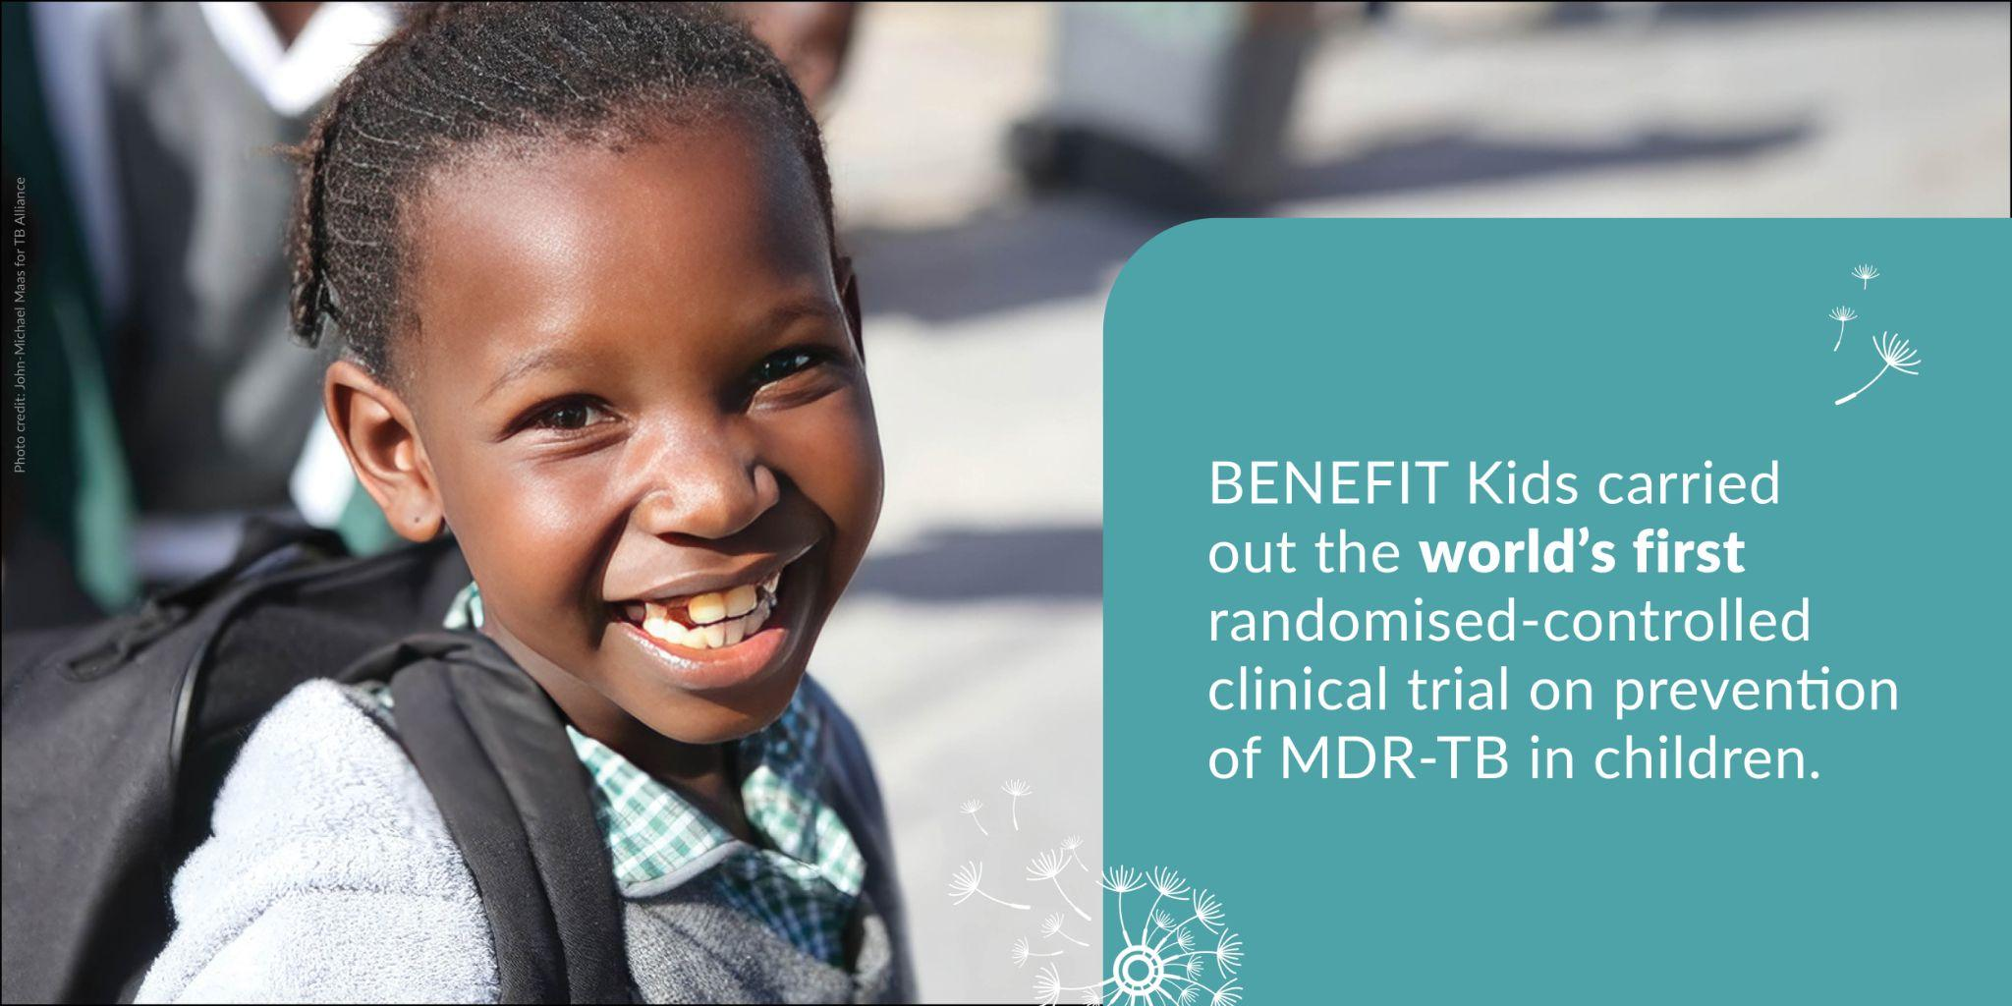
Download this graphic here
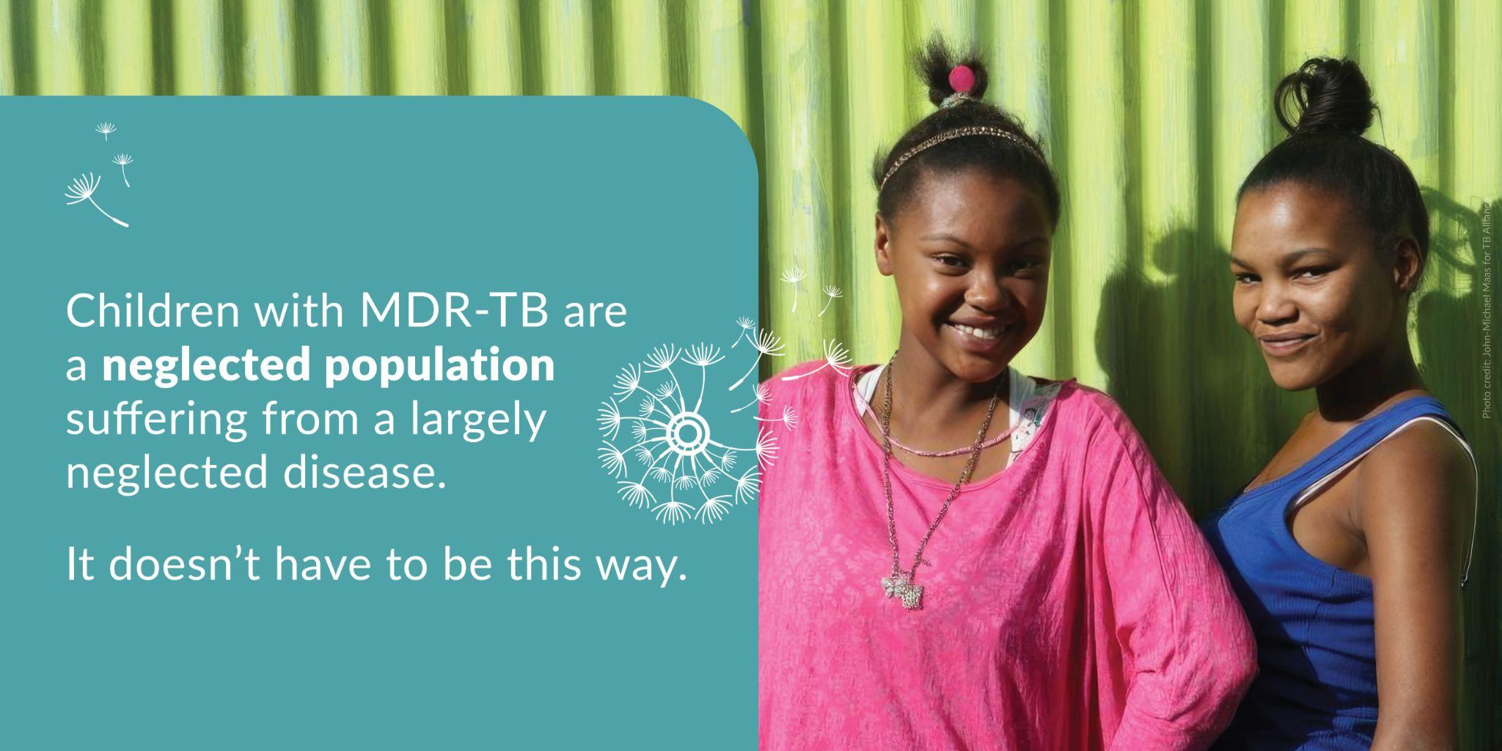
Download this graphic here
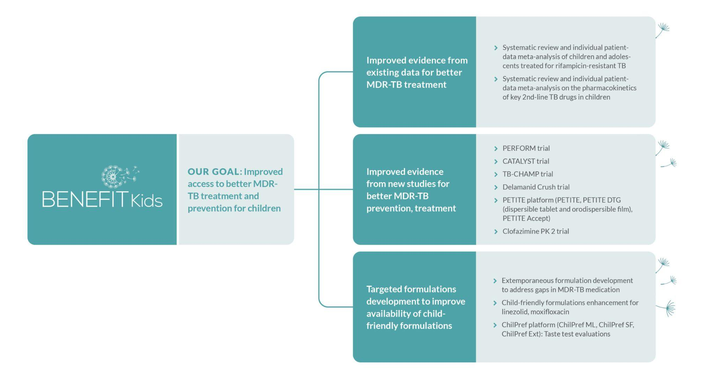
Download this infographic here

