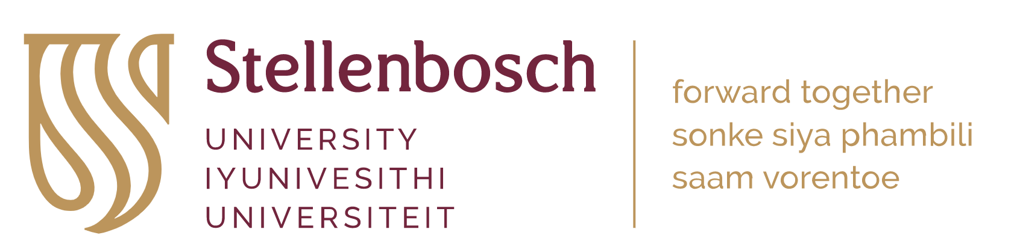

Post-doctoral Fellowship

Water-use and carbon sequestration strategies in variously competing eucalypts up to canopy closure

The research project
South Africa has very few long-term, intensively monitored experiments in managed forest environments. Just such an experiment is in the process of being implemented as part of the Hans Merensky Chair in Advanced Modelling of Growth and Wood Formation in Eucalypts (EucXylo) at Stellenbosch University. This new experiment, called the IMPACT Open-Air Laboratory will be located at Somerset West in the Western Cape of South Africa. The focus of this new experimental facility and associated research program will be the intensive monitoring of growth and ecophysiology of several eucalypt species experiencing varied levels of between-tree competition. A wide range of sensing equipment will be installed at the site, including dendrometers, sap flow sensors and environmental sensors such as soil water content probes. The experiment will also make extensive use of remote sensing systems. These systems will be implemented across all plots in three replications on an 11-ha site.
This post-doctoral fellowship will focus on understanding water-use and carbon sequestration strategies and efficiencies between in young eucalypts, from planting to about 2 years, grown at differing levels of physiological stress. Discussion around variations to this theme are very welcome. The project will explore this topic using four distinct species of Eucalyptus grown at highly varied levels of stand density (ranging from 5m X 5m to 1m X 1m m spacing) and therefore competition. Regular campaigns to collect data on leaf- and plant-level responses will supplement the data obtained from on-site sensors. The fellowship will include the installation and monitoring of state of the art sensing systems and the use of tools such as portable photosynthesis systems to understand short-term responses in leaf- to canopy-scale processes and phenomena.

DUTIES
This post-doctoral fellowship will involve:
- Working closely with the principal investigator of the project to plan measurements, sampling, data acquisition and management approaches, as well as laboratory analyses.
- Regular site visits (usually with students or technical staff) to undertake and oversee measurements and sampling. This may include periodic early morning or late-night sampling or measurement campaigns.
- Sourcing, calibrating, testing and installing monitoring equipment (with assistance from project technicians) such as dendrometers, sap flow systems, eddy covariance set-ups, weather stations, etc.
- Leading proposal development to bring in additional funds for research activities or travel where possible.
- Co-supervision of at least one student.
- Some assistance with under-graduate teaching in the Department of Forest and Wood Science.
- Publication, as lead author, of at least two peer-reviewed papers reporting findings on the research topic, as well as co-authorship with students also working at IMPACT.

Location
The incumbent will be based full time at the Department of Forest & Wood Science (DFWS) at Stellenbosch University (SU). SU celebrated its centenary in 2018, is widely acknowledged as one of Africa’s premier tertiary education and research institutions (visit www.sun.ac.za for more information). Staff and students at the University enjoy a relaxed and pleasant lifestyle, close to mountains and sea. Attracting students from around the world, and particularly Africa, and with strong international linkages and collaborations, the DFWS prides itself on research excellence with a diverse, friendly culture.

Requirements and qualifications
- A recognized Ph.D. in forest science, ecology, horticulture, plant physiology, botany, or related field within the last five years.
- Up-to-date knowledge in modern scientific data collection, data management, and data/statistical analysis.
- Excellent communication and interpersonal skills to be able to interact effectively with students, scientists, and stakeholders.
- A high level of written and verbal communication skills in English are essential.
- Ability to function in a multicultural and multilingual environment, ability to work well both independently and as part of a team and take initiative.
- Valid South African driver’s license.
- At least one high quality papers already published in the scientific literature.

Recommendations
- Knowledge of the R system for statistical computing, Python, or other programming languages.
- Familiarity with electronic data-logging and sensing equipment, including systems and hardware like Campbell Scientific.
- Working knowledge of electronics.
- Some teaching experience.

Contract duration and commencement
The research stipend is granted for a one-year period which can be extended to a second year, performance dependent. The base stipend is R340,000 per annum. Although the stipend is fully covered by the project, the successful incumbent will be encouraged to apply for additional funding to expand the scope of the research.
Please note that post-doctoral fellows are not appointed as employees in South Africa and their fellowships are awarded tax free, and they are not eligible for standard employee benefits. For more information about post-doctoral fellowships at Stellenbosch visit http://www.sun.ac.za/english/research-innovation/Research-Development/postdocs.
This position is based at Stellenbosch campus. The incumbent is expected to work full time on campus or at the experimental field site during the work day, although some flexibility in working location can be negotiated.
Commencement: March or April 2024

Application procedure
Application closing date: End of January 2024
Please send by email to Dr. David Drew (drew@sun.ac.za) the following documents:
- A brief cover letter providing motivation for your application.
- A brief referenced essay (max two pages) in which you explore the potential effects of varied levels of between-tree competition on key eco-physiological processes in eucalypts.
- Current, comprehensive CV with full publication list.
- Copies of doctoral degree certificate and other relevant degree certificates and grades obtained (where applicable).
- Contact details of at least two professional referees.
Any questions about the position can be addressed to Dr. Drew at the same email address. For questions about visas and international relocation to South Africa please contact : Stellenbosch University International immigrations@sun.ac.za and copy postdocinfo@sun.ac.za.
Applicants who have not received a response within 14 days of having sent in their application, please accept that your application has not been successful. Short-listed applicants will be contacted to arrange an interview. These candidates may be requested to provide additional information/submissions, and to undergo certain biometric/literacy/other tests.

