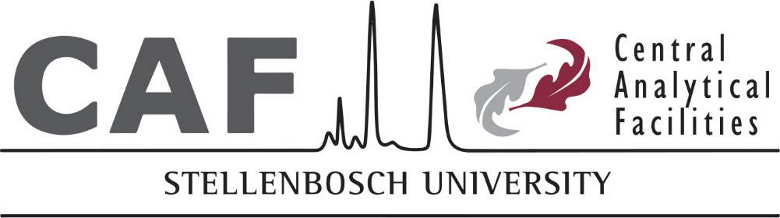

Fluorescence Microscopy Unit

Regulations for use of the unit during COVID-19 lockdown
All national regulations shall apply, as well as all the regulations of the University and the applicable faculty, whichever lockdown level is applicable. This includes the compulsory wearing of a face mask at all times, possession of a valid permit to perform work, applying social distancing and any other measures specified by government.
- No user shall be allowed to enter the unit if not arranged with the manager of the unit and it remains the discretion of the unit staff to allow access.
- If you have been in contact with a known or suspected COVID-19 case; or if you exhibit any symptoms of an acute flu-like illness (sore throat, cough, shortness of breath, or fever) you are not allowed to use our laboratories until you have been cleared to do so by a healthcare professional.
- CAF staff will perform the analysis/imaging on behalf of companies and any non-trained users and the data will be sent to the user. It will not be possible to be present in the lab whilst samples are being analysed.
- For clients sending samples to CAF for analysis, please wash your hands before handling and packing the samples and wear a face mask at all times while preparing samples. Samples are to be delivered at a pre-arranged time to a delivery point indicated on the booking system and will be collected as soon as the user confirms the delivery to CAF staff via whatsapp.
- No discussion about the analyses should take place face-to-face upon delivery and no notes should accompany the samples. A detailed explanation of the samples, the required analyses and procedures to follow and any other relevant information should be sent to the staff via e-mail. Discussions should take place either via e-mail, online video calls or telephone conversations only.
- Only fully trained users with SU permits allowing them to use the CAF unit, directly performing analyses may enter the lab when arranged with the unit staff, other interested parties may not accompany them.
- Users are requested to wash their hands with soap and water or disinfectant upon arrival to our CAF unit. A user should put on a fresh pair of gloves after washing hands and discard the gloves inside out in the designated red bins after the session.
- If a staff member is present the user’s temperature will be taken, else the user need to fill in the entry register at the door, indicating the last time a temperature has been taken and the temperature reading.
- All surfaces that are touched by a user should be wiped with 70% ethanol before and after the session. Bottles of ethanol will be provided in the lab and a comprehensive list of surfaces possibly touched during the session will be placed next to each instrument. General surfaces include door handles, bench tops, mouse, keyboard, alarm code buttons, the fridge door, any reagents and pipettes used etc. Do not spray ethanol directly onto electronic equipment. Rather use a paper towel sprayed with ethanol to wipe sensitive parts (especially keyboards).
- No back to back bookings will be allowed. There will be 30 minutes break between sessions, to allow approximately 20 minutes for sterilisation after a session and then for the person to leave the unit before the next person arrives. You are not allowed to continue analyses when your booked time has expired to ensure there is enough time to sterilise and leave on time.
- No user should arrive early. If sample preparation needs to be done, the booking should include this time. The same applies to the use of the on-stage incubator. No-one is to enter the unit without a booking, not even to collect reagents from the fridge, to collect data or use the analysis stations. These need to be booked, just as the equipment are booked.
- There may be no more than one person in a room in the unit at any given time. If there is a case where users come into close proximity to other users the required 2 meters distance between people should be applied.

