Irene Residence recognizes the struggle faced by marginalized groups and we stand against anything that violates or infringes on anyone’s human rights or safety. We take pride in being a refuge and a space of healing for anyone who enters our Residence. Irene Residence does not tolerate any form of oppression or violations of one’s humanity. Through our leadership, events and committees, we aim to being a community that promotes inclusivity, diversity and representation for all, while also educating and creating awareness for causes that promote restoration and equality
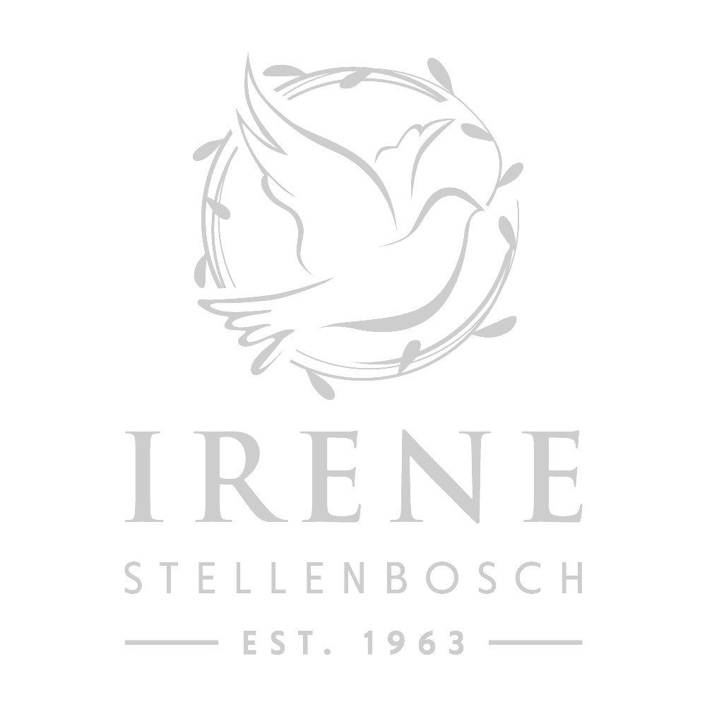
IRENE INCLUSIVITY STATEMENT

STELLENBOSCH UNIVERSITY

